Reporting and Mitigating Unanticipated
Problems and Adverse Events Guidance

Accommodations for individuals with disabilities in accessing these policies are available upon request by emailing accessiblepolicy@wcupa.edu

Note: This guidance summarizes the Office of Human Research Protection’s (OHRP) current thinking on this topic and should be viewed as recommendations unless specific regulatory requirements are cited. The use of the word must in OHRP guidance means that something is required under HHS regulations at 45 CFR part 46. The use of the word should in OHRP guidance means that something is recommended or suggested, but not required. More information can be found at (Unanticipated Problems Involving Risks & Adverse Events Guidance. HHHS.gov, https://www.hhs.gov/ohrp/regulations-and-policy/guidance/reviewing-unanticipated-problems/index.html#AB). OHRP is available to discuss alternative approaches at 240-453-6900 or 866-447-4777.

Purpose and Scope [1]
This document applies to non-exempt human subjects research conducted or supported by the US Department of Health and Human Services (HHS). It provides guidance on HHS regulations for the protection of human research subjects at 45 CFR part 46 related to the review and reporting of (a) unanticipated problems involving risks to subjects or others (hereinafter referred to as unanticipated problems); and (b) adverse events. In particular, this guidance clarifies that only a small subset of adverse events occurring in human subjects participating in research are unanticipated problems that must be reported under 45 CFR part 46. The guidance is intended to help ensure that the review and reporting of unanticipated problems and adverse events occur in a timely, meaningful way so that human subjects can be better protected from avoidable harms while reducing unnecessary burden.

Guidance

- Unanticipated Problems

The phrase “unanticipated problems involving risks to subjects or others” is found but not defined in the HHS regulations at 45 CFR part 46. OHRP considers unanticipated problems, in general, to include any incident, experience, or outcome that meets all of the following criteria:
- unexpected (in terms of nature, severity, or frequency) given (a) the research procedures that are described in the protocol-related documents, such as the IRB-approved research protocol and informed consent document; and (b) the characteristics of the subject population being studied;
- related or possibly related to participation in the research (in this guidance document, possibly related means there is a reasonable possibility that the incident, experience, or outcome may have been caused by the procedures involved in the research); and
- suggests that the research places subjects or others at a greater risk of harm (including physical, psychological, economic, or social harm) than was previously known or recognized.

OHRP recognizes that it may be difficult to determine whether a particular incident, experience, or outcome is unexpected and whether it is related or possibly related to participation in the research. OHRP notes that an incident, experience, or outcome that meets the three criteria above generally will warrant consideration of substantive changes in the research protocol or informed consent process/document or other corrective actions in order to protect the safety, welfare, or rights of subjects or others. Examples of corrective actions or substantive changes that might need to be considered in response to an unanticipated problem include:
- changes to the research protocol initiated by the investigator prior to obtaining IRB approval to eliminate apparent immediate hazards to subjects;
- modification of inclusion or exclusion criteria to mitigate the newly identified risks;
- implementation of additional procedures for monitoring subjects;
- suspension of enrollment of new subjects;
- suspension of research procedures in currently enrolled subjects;
- modification of informed consent documents to include a description of newly recognized risks; and
- provision of additional information about newly recognized risks to previously enrolled subjects.
As discussed in the sections II and III below, only a small subset of adverse events occurring in human subjects participating in research will meet these three criteria for an unanticipated problem.

Furthermore, there are other types of incidents, experiences, and outcomes that occur during the conduct of human subjects research that represent unanticipated problems but are not considered adverse events. For example, some unanticipated problems involve social or economic harm instead of the physical or psychological harm associated with adverse events. In other cases, unanticipated problems place subjects or others at increased risk of harm, but no harm occurs.

Examples of Unanticipated Problems that Do Not Involve Adverse Events and Need to be Reported Under the HHS Regulations at 45 CFR Part 46:
- An investigator conducting behavioral research collects individually identifiable sensitive information about illicit drug use and other illegal behaviors by surveying college students. The data are stored on a laptop computer without encryption, and the laptop computer is stolen from the investigator’s car on the way home from work. This is an unanticipated problem that must be reported because the incident was (a) unexpected (i.e., the investigators did not anticipate the theft); (b) related to participation in the research; and (c) placed the subjects at a greater risk of psychological and social harm from the breach in confidentiality of the study data than was previously known or recognized.
- As a result of a processing error by a pharmacy technician, a subject enrolled in a multicenter clinical trial receives a dose of an experimental agent that is 10-times higher than the dose dictated by the IRB-approved protocol. While the dosing error increased the risk of toxic manifestations of the experimental agent, the subject experienced no detectable harm or adverse effect after an appropriate period of careful observation. Nevertheless, this constitutes an unanticipated problem for the institution where the dosing error occurred that must be reported to the IRB, appropriate institutional officials, and OHRP because the incident was (a) unexpected; (b) related to participation in the research; and (c) placed subject at a greater risk of physical harm than was previously known or recognized.
- Subjects with cancer are enrolled in a phase 2 clinical trial evaluating an investigational biologic product derived from human sera. After several subjects are enrolled and receive the investigational product, a study audit reveals that the investigational product administered to subjects was obtained from donors who were not appropriately screened and tested for several potential viral contaminants, including the human immunodeficiency virus and the hepatitis B virus. This constitutes an unanticipated problem that must be reported because the incident was (a) unexpected; (b) related to participation in the research; and (c) placed subjects and others at a greater risk of physical harm than was previously known or recognized.

The events described in the above examples were unexpected in nature, related to participation in the research, and resulted in new circumstances that increased the risk of harm to subjects. In all of these examples, the unanticipated problems warranted consideration of substantive changes in the research protocol or informed consent process/document or other corrective actions in order to protect the safety, welfare, or rights of subjects. In addition, the third example may have presented unanticipated risks to others (e.g., the sexual partners of the subjects) in addition to the subjects. In each of these examples, while these events may not have caused any detectable harm or adverse effect to subjects or others, they nevertheless represent unanticipated problems and should be promptly reported to the IRB, appropriate institutional officials, the supporting agency head and OHRP in accordance with HHS regulations at 45 CFR 46.103(a) and 46.103(b)(5).

- Adverse Events

The HHS regulations at 45 CFR part 46 do not define or use the term adverse event, nor is there a common definition of this term across government and non-government entities. In this guidance document, the term adverse event in general is used very broadly and includes any event meeting the following definition:
Any untoward or unfavorable medical occurrence in a human subject, including any abnormal sign (for example, abnormal physical exam or laboratory finding), symptom, or disease, temporally associated with the subject’s participation in the research, whether or not considered related to the subject’s participation in the research (modified from the definition of adverse events in the 1996 International Conference on Harmonization E-6 Guidelines for Good Clinical Practice).

Adverse events encompass both physical and psychological harms. They occur most commonly in the context of biomedical research, although on occasion, they can occur in the context of social and behavioral research.

In the context of multicenter clinical trials, adverse events can be characterized as either internal adverse events or external adverse events. From the perspective of one particular institution engaged in a multicenter clinical trial, internal adverse events are those adverse events experienced by subjects enrolled by the investigator(s) at that institution, whereas external adverse events are those adverse events experienced by subjects enrolled by investigators at other institutions engaged in the clinical trial. In the context of a single-center clinical trial, all adverse events would be considered internal adverse events.

In the case of an internal adverse event at a particular institution, an investigator at that institution typically becomes aware of the event directly from the subject, another collaborating investigator at the same institution, or the subject’s healthcare provider. In the case of external adverse events, the investigators at all participating institutions learn of such events via reports that are distributed by the sponsor or coordinating center of the multicenter clinical trials. At many institutions, reports of external adverse events represent the majority of adverse event reports currently being submitted by investigators to IRBs.

- Relationship between Unanticipated Problems and Adverse Events

In OHRP’s experience, most IRB members, investigators, and institutional officials understand the scope and meaning of the term adverse event in the research context, but lack a clear understanding of OHRP’s expectations for what, when, and to whom adverse events need to be reported as unanticipated problems, given the requirements of the HHS regulations at 45 CFR part 46.

The following Venn diagram summarizes the general relationship between adverse events and unanticipated problems:

The diagram illustrates three key points:
- The vast majority of adverse events occurring in human subjects are not unanticipated problems (area A).
- A small proportion of adverse events are unanticipated problems (area B).
- Unanticipated problems include other incidents, experiences, and outcomes that are not adverse events (area C).
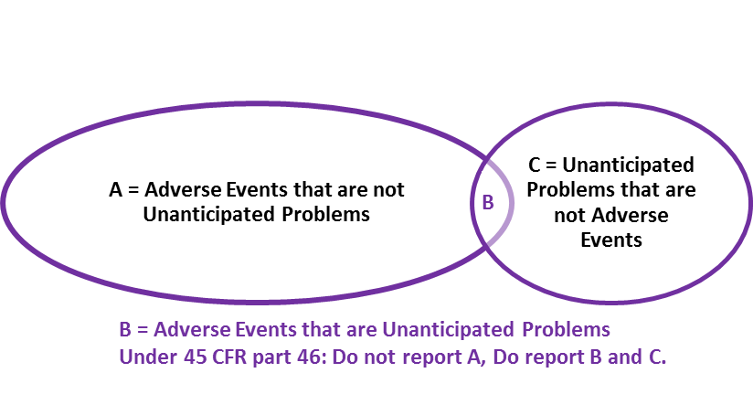

The key question regarding a particular adverse event is whether it meets the three criteria described in section I and therefore represents an unanticipated problem. To determine whether an adverse event is an unanticipated problem, the following questions should be asked:
  - Is the adverse event unexpected?
  - Is the adverse event related or possibly related to participation in the research?
  - Does the adverse event suggest that the research places subjects or others at a greater risk of harm than was previously known or recognized?
If the answer to all three questions is yes, then the adverse event is an unanticipated problem and must be reported to appropriate entities under the HHS regulations at 45 CFR 46.103(a) and 46.103(b)(5).

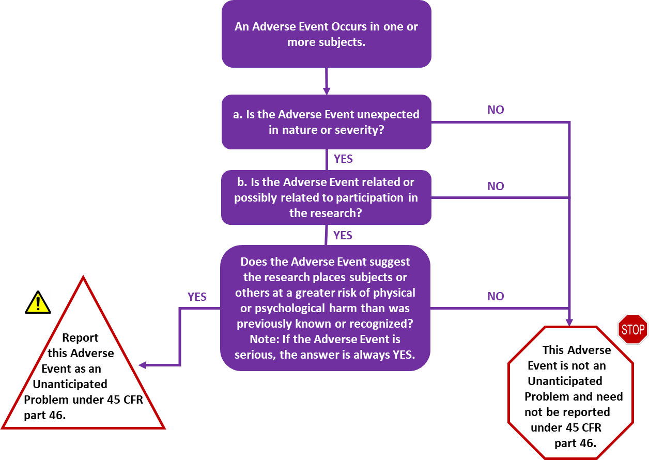

Determining Whether the Adverse Event is Related or Possibly Related to the Research

Adverse events may be caused by one or more of the following:
- the procedures involved in the research;
- an underlying disease, disorder, or condition of the subject; or
- other circumstances unrelated to either the research or any underlying disease, disorder, or condition of the subject.
In general, adverse events that are determined to be at least partially caused by (i) would be considered related to participation in the research, whereas adverse events determined to be solely caused by (ii) or (iii) would be considered unrelated to participation in the research.

For example, for subjects with cancer participating in oncology clinical trials testing chemotherapy drugs, neutropenia and anemia are common adverse events related to participation in the research. Likewise, if a subject with cancer and diabetes mellitus participates in an oncology clinical trial testing an investigational chemotherapy agent and experiences a severe hypoglycemia reaction that is determined to be caused by an interaction between the subject’s diabetes medication and the investigational chemotherapy agent, such a hypoglycemic reaction would be another example of an adverse event related to participation in the research.

In contrast, for subjects with cancer enrolled in a non-interventional, observational research registry study designed to collect longitudinal morbidity and mortality outcome data on the subjects, the death of a subject from progression of the cancer would be an adverse event that is related to the subject’s underlying disease and is unrelated to participation in the research. Finally, the death of a subject participating in the same cancer research registry study from being struck by a car while crossing the street would be an adverse event that is unrelated to both participation in the research and the subject’s underlying disease.

Determinations about the relatedness of adverse events to participation in research commonly result in probability statements that fall along a continuum between definitely related to the research and definitely unrelated to participation in the research. OHRP considers possibly related to participation in the research to be an important threshold for determining whether a particular adverse event represents an unanticipated problem. In this guidance document, OHRP defines possibly related as follows:
There is a reasonable possibility that the adverse event may have been caused by the procedures involved in the research (modified from the definition of associated with use of the drug in FDA regulations at 21 CFR 312.32(a)).

OHRP recognizes that it may be difficult to determine whether a particular adverse event is related or possibly related to participation in the research.
Many individual adverse events occurring in the context of research are not related to participation in the research and, therefore, do not meet the second criterion for an unanticipated problem and do not need to be reported under the HHS regulations 45 CFR part 46.103(a) and 46.103(b)(5)

Determining Whether the Adverse Event Suggest That the Research Places Subjects or Others at a Greater Risk of Harm Than Was Previously Known or Recognized

The first step in assessing whether an adverse event meets the third criterion for an unanticipated problem is to determine whether the adverse event is serious.
In this guidance document, OHRP defines serious adverse event as any adverse event that:
- results in death;
- is life-threatening (places the subject at immediate risk of death from the event as it occurred);
- results in inpatient hospitalization or prolongation of existing hospitalization;
- results in a persistent or significant disability/incapacity;
- results in a congenital anomaly/birth defect; or
- based upon appropriate medical judgment, may jeopardize the subject’s health and may require medical or surgical intervention to prevent one of the other outcomes listed in this definition (examples of such events include allergic bronchospasm requiring intensive treatment in the emergency room or at home, blood dyscrasias or convulsions that do not result in inpatient hospitalization, or the development of drug dependency or drug abuse).
(Modified from the definition of serious adverse drug experience in FDA regulations at 21 CFR 312.32(a).)

OHRP considers adverse events that are unexpected, related or possibly related to participation in research, and serious to be the most important subset of adverse events representing unanticipated problems because such events always suggest that the research places subjects or others at a greater risk of physical or psychological harm than was previously known or recognized and routinely warrant consideration of substantive changes in the research protocol or informed consent process/document or other corrective actions in order to protect the safety, welfare, or rights of subjects.

IRB Responsibility
IRBs have authority to suspend or terminate approval of research that, among other things, has been associated with unexpected serious harm to subjects (45 CFR 46.113). In order for IRBs to exercise this important authority in a timely manner, they must be informed promptly of those adverse events that are unexpected, related or possibly related to participation in the research, and serious (45 CFR 46.103(b)(5)).

Sources

- Unanticipated Problems Involving Risks & Adverse Events Guidance (2007). HHHS.gov, https://www.hhs.gov/ohrp/regulations-and-policy/guidance/reviewing-unanticipated-problems/index.html#AB.
- Ohio State University Event Reporting. https://orrp.osu.edu/irb/investigator-guidance/event/.

Reviewed by: Office of Sponsored Research and Sponsored Programs, Academic Deans, WCU IRB

Policy Owner: Vice Provost for Research and Creative Activity, Office of Research and Sponsored Programs

Approved by: Jeffery L. Osgood, Jr. Deputy Provost & Vice President for Academic Operations

Effective Date: 08/19/2022

Next Review Date: 08/01/2025

History
Initial Approval: 08/19/2022

