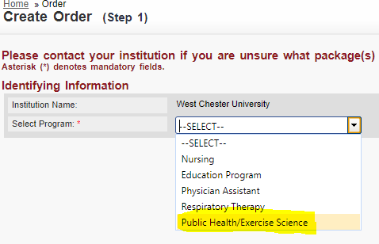
Click “load packages”
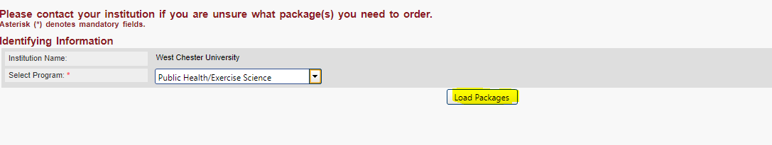
You put a check mark next to “10 panel drug screen”
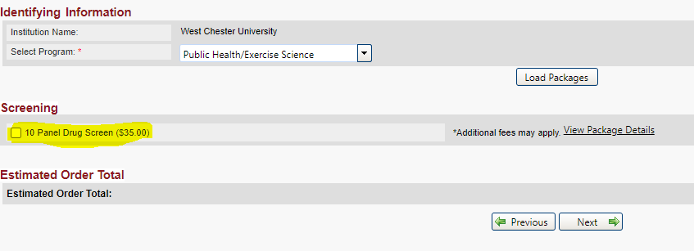
You’ll re-verify your personal information
Then you’ll select a drug screen location from the map:
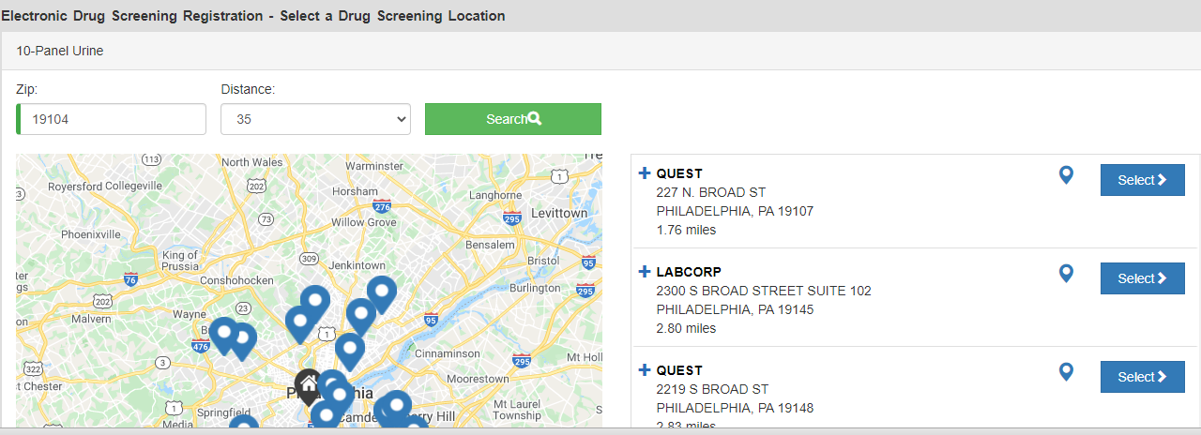

If you have additional questions please call American DataBank at 1-800-200-0853.

