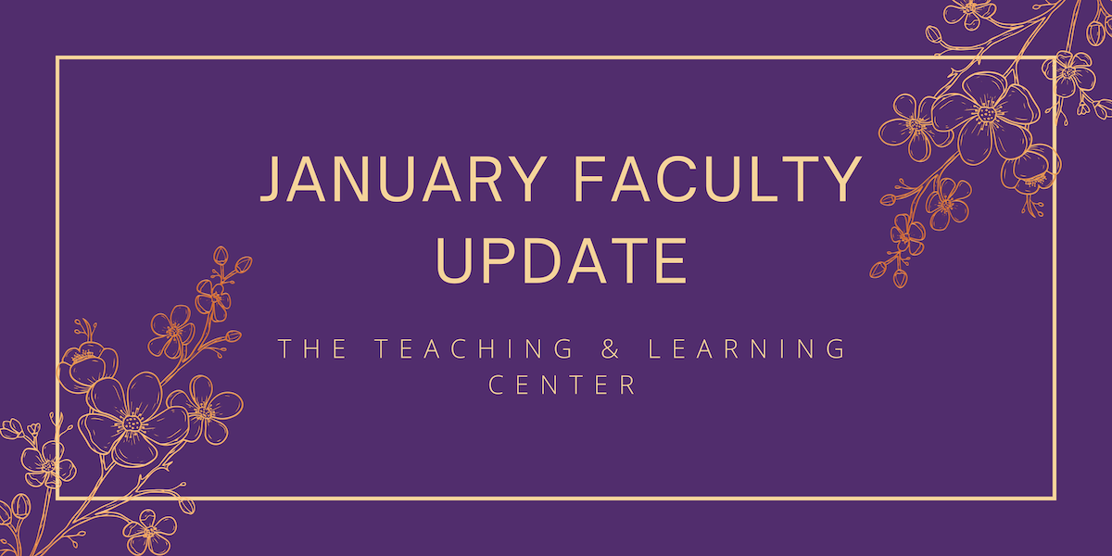

Welcome back!

We hope your winter break has been restful and the new year finds you well. All of us at the Teaching and Learning Center look forward to spending another spring supporting faculty to enhance teaching strategies and techniques.

We're excited to introduce new opportunities for learning and collaboration to the campus community this semester; to see what we have in store, keep reading!

Open Initiatives

Efficiency Meets Design: D2L Homepages Made Easy
We are seeking faculty willing to pilot new D2L Homepage Templates in Spring 2024. The Teaching & Learning Center (TLC) and IS&T’s EdTech and User Services team have collaborated to develop D2L course homepage templates, with the aim of providing students with a consistent learning environment and supporting faculty in the set up and design of their course sites.

All faculty are eligible to participate. For more information, see the full program description on our website, or if you are interested in participating in this pilot, please complete the Spring 2024 Pilot Registration Form by Friday, January 12.

Padlet Pilot Program
The Teaching & Learning Center is excited to offer the Padlet Pilot Program again during the Spring 2024 semester! Padlet is an online visual board that can be used to organize and share content. It’s a great tool for facilitating both collaborative and individual activities and projects. The Teaching & Learning Center has procured a trial license, complete with D2L Integration.

Registration for the Padlet Pilot Program is open through Friday, February 9. To learn more, please visit the Padlet Pilot Program page on our website.

CELT Professional Development Award
CELT is inviting proposals for its annual professional development award of up to $2,000 to advance improved student learning as part of WCU’s strategic plan. All tenured, tenure track, and regular part time faculty are eligible to apply. Proposals are due Friday, March 1.

Full guidelines, as well as a link to the application portal, can be found in the CELT Professional Development Funds Program Overview. Address any questions to CELT co-chairs Sandy Sarcona (asarcona@wcupa.edu) and Dawn Patterson (dpatterson@wcupa.edu).

Teaching Circle: Grading Practices and Extended Reality
A teaching circle is a group of faculty who collectively explore a teaching topic of interest and work together to create a product reflecting their learning experience. The group collaboratively determines what product or products they wish to create at the start of the process.

In Spring 2024, teaching circles will be exploring the topics of Grading Practices and Extended Reality. For more information, see the full program descriptions on our website.

Upcoming Events & Workshops

Faculty Fusion: Hot Topics with the TLC
Need help transitioning out of holiday mode before the Spring semester? Looking for ways to keep Winter class momentum rolling? Register today for Faculty Fusion!
- When: January 17, 2024 from 9:00am to 1:00pm
- Where: The Foundation
- What: An in-person set of three interactive panels covering hot topics to help you prepare for the new semester.

Featured "hot" topics:
- Pedagogy of Care: Supporting Mental Health through Instructional Practices
- Using AI for Teaching
- Addressing Micro-Aggressions in the Classroom

Each session will include 30 minutes of presentation from a panel of WCU faculty experts, followed by 20 minutes of Q&A and table conversations with your peers. Coffee and lunch will be provided.

Registration Open: CELT Book Club
Register to join the Committee for Excellence in Teaching and Learning’s Spring Book Club! This semester, CELT is reading Sarah Rose Cavanagh’s Mind Over Monsters: Supporting Youth Mental Health with Compassionate Challenge (Beacon Press, 2023).

More information, including meeting dates and modalities, can be found on our Book Clubs page. To join us, complete the Spring 2024 Book Club registration form! Space is limited.

Registration Open: Teaching Strides
Teaching Strides will return in Spring 2024. To better accommodate busy schedules, we are asking those interested in participating to sign up, and then we will work to find a common time for our weekly walk.

Program Updates

TLC Feedback Survey
The Teaching and Learning Center relies on your feedback to make sure our programming and resources support, celebrate, and inspire excellence and innovation in teaching! We invite you to share your thoughts and insights regarding the resources and opportunities we've provided this semester.

The TLC Feedback Survey should take about 10 – 15 minutes to complete. Responses are anonymous and will be used to improve TLC programs and services.

New Navigating Digital Learning Tutorial on Generative AI
Introduction to Generative Artificial Intelligence is a new tutorial for students available now as part of Navigating Digital Learning. The tutorial overviews generative artificial intelligence including benefits, pitfalls, and how these types of tools might be used by students at West Chester University. All NDL tutorials provide users with a certificate of completion once the tutorial task is complete.

Online Faculty Development Program
Congratulations to the following faculty for earning their CAPC Distance Education Certification!
- Patricia Crump
- Paul Harris
- Danielle Kronmuller-Harvey
- Edward Kubachka
- Julia Linden-Chirlian
- Susan Lloyd
- Lisa Millhous
- Kyle Vealey
- Jordin Clark
Faculty interested in completing OFD can now self-enroll into the program’s D2L site using the Discover feature and start working when it fits their schedule

Stay Connected

ODLI on Air Podcast
How much of the podcast’s 15 hours of content have you listened to? Our latest episodes:
- On-Campus HR Internship Program with Dr. Blythe Rosikiewicz and Emily Meinhart
- Universal Design for Learning with Dr. Beth Foster
- Recap of the 2023 D2L Fusion Conference
The new season kicks off on January 17 with Quality Matters Peer and Master Reviewer Roles with Dr. Veronica Wilbur, and then President Fiorentino joins us on January 31.

Connect with Us
The Teaching and Learning Center is far more than just a newsletter! Our website hosts a variety of teaching resources and our full Event Calendar. To get in touch, feel free to send us an email, or stop by our drop-in hours to speak live with one of our designers.

