INTERDISCIPLINARY MINOR IN SUSTAINABILITY & RESILIENCE
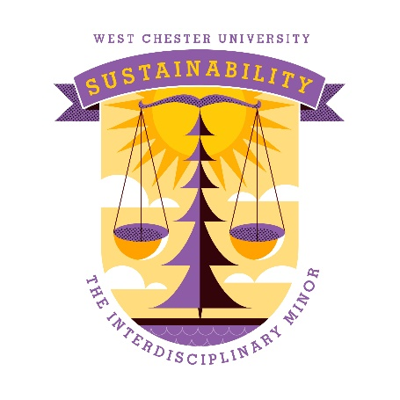
Advising sheet

Jump to advising planner grid, below.
Course list & requirements

Required courses:
- SUS100, Introduction to Sustainability & Resilience. Interdisciplinary designation.*
- IDS450, Internship
Until we have enough students to be able to offer SUS400, we are substituting an internship, IDS450.
Four electives:
- can be sustainability pathway classes (gen ed).
- two must be advanced standing courses (either at the 300/400 level or have at least two pre-requisites).
- one must be a sustainability-related course in student’s major. You can choose from the approved list or make a case for counting a certain course to meet this requirement, since not all majors yet have sustainability-related courses.
- you may not take more than two courses with the same prefix.
- you may petition to have a class not on the list below count for an elective.
- approved electives: see approved list below
- other eligible classes (may be approved by the director on case-by-case basis): see other class list below

Sustainability minor planner

Course requirement | Course name/number | Semester completed | Identify which course is in your major:
SUS100

SUS400 (current substitute = IDS450, Interdisciplinary internship)

Elective 1:

Elective 2:

Elective 3: advanced standing

Elective 4: advanced standing

Approved electives
*Course has also been approved as a General Education Sustainability Pathway course.

ANT277/NTD277* - Sustainable Food Systems | ESS102* – Humans & the Environment, also SCB and ENV
ANT367* - Archeology and Environment | ESS127 – Movies, Media, and Entertainment from an Earth and Space Science Perspective
BIO270 - Ecology | GEO205* - Geography of Agriculture, Food and Sustainability
BIO315 - Terrestrial Ecosystem Ecology | GEO230* - Environmental Conservation and Sustainability
BIO415 - Tropical Ecology and Conservation | GEO332- Environmental Crises
BIO471 - Wetlands | GEO334 - Sustainable Living
BIO473 - Conservation Biology | GEO336 - Environmental Planning
CHE403 - Chemistry of the Environment | GEO338 - Environmental Applications of Geographic Information Systems (GIS)
COM335 – Corporations and Social Impact | HON314 - Science, Technology and Environmental Systems (must be in an HON program)
CRJ325 – Animal Cruelty | MGT313* - Business & Society
ECO385 - Environmental & Resource Economics | NTD325 - The Food Chain
EDO400 - Environmental Sustainability Educ: History, Theory & Practice | PAX200 – Introduction to Peace and Conflict Studies
EDO415 - History of Conservation | PHI451 - Religion and Ecology
EDO420 - Outdoor and Place-Based Education | PHI480 - Environmental Ethics
EDO425 - Independent Studies in Environment Educ | PSC325 – Campaigns and Elections
EDO450 - Education for Sustainability: Methods and Field Experience | PSC354 - Sustainability Politics and Policy
EDO498 - Workshop In Environmental Education | PSY/RUX215 - Liberation Psychology: Sustaining Community Change
ENG305* - Environmental Rhetoric & Advocacy | RUX110 – Introduction to Urban Community Change
ENV324 – Environmental Sustainability | SCI100 - Climate Change
ENV447 – Environmental Regulations | SOC245* - Environmental Sociology
 | SOC309* - Sustainable WCU & Beyond
 | WOS260* - Globalization and Ethics of Sustainability

Other eligible classes
These may be approved by the director on case-by-case basis; they will not automatically appear in your Degree Audit

ARH 401. Contemporary Art | NTD 305. Vegetarian Nutrition
BIO 277. Vertebrate Ecology | NTD 315. Food - Mind - Spirit
BIO 476. Freshwater Ecology | NTD 415. Community Nutrition
BIO 470. Population Biology | PAX 200. Introduction to Peace and Conflict Studies
CRJ 318. Environmental Crime | PAX 377. Community Organizing: Strategies and Practice
CRJ 325. Animal Cruelty | PHY 125. Theology and Science: Enemies or Partners
EXS 487. Physical Activity and the Environment | PLN 316. Planning for Resilient Communities and Natural Disasters
ESS 127. Movies, Media, and Entertainment from an Earth and Space Science Perspective | PLN 336. Environmental Planning
ESS 128. The Science of Natural Disasters | PSC 325. Campaigns and Elections
ESS 130. Our Ocean | PSC 351. Energy and the Political Process
ESS 336. Environmental Geology | PSC 371. State and Local Government
ENV 447. Environmental Regulations | PSY 400. Senior Seminar (special topic): Social Psychology of Climate Change and Dystopian Future
ENV 451. Environmental Toxicology | RUX 110. Introduction to Urban Community Change
ENV 462. Water Quality and Health | RUX 215. Liberation Psychology: Sustaining Community Change
MDC 420. Mass Media & Social Protest | RUX 377. Community Organizing: Strategies and Practice
NTD 304. Global Nutrition | WOS 260. Globalization and the Ethics of Sustainability
 | WOS 366. Gender, Labor and Globalization

